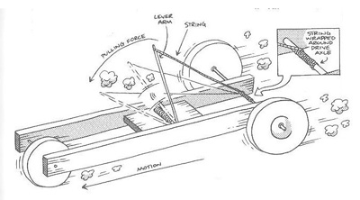

Technology and Enterprise
Mousetrap Racer Marking Rubric

Name: _______________________________________________________________

Category | 10 | 5 | 3 | 0
Build Diary | A comprehensive build diary is submitted. | Build diary is complete, but not comprehensive. | An incomplete build diary is submitted. | No build diary provided.
Team Poster | A complete team poster that shows considerable effort, including name and motto is submitted. | A complete team poster, including name and motto is submitted. | Team poster is submitted, but does not contain team name and/or motto. | No team poster is provided.
Mousetrap Racer Design | More than 3 designs/justified design revisions are submitted, one of which is the same as the constructed racer. | 2 designs/justified design revisions are submitted, one of which is the same as the constructed racer. | 1 justified design is submitted, it is the same as the constructed racer. | No designs are submitted or the design does not match the constructed racer.
Distance Travelled | Your racer travels the furthest distance. | Your racer travels at least 2/3 the distance of the winner. | Your racer travels at least 1/3 the distance of the winner. | The racer does not leave the start line.
A >35 | B >25 | C >16 | D >9 | E <9

Total Mark: /40 Grade:

